1. Show that you have WebStorm installed on your machine

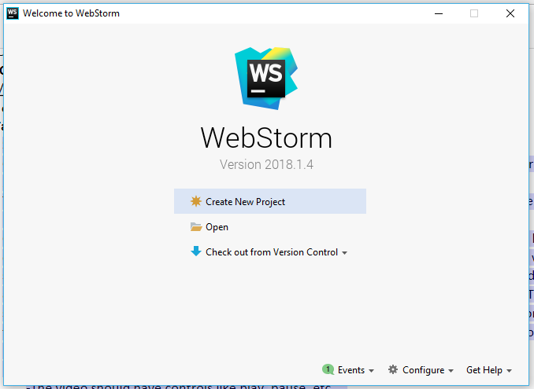

2.Create GitHub Account. Create a repository in remote GitHub. Clone it to local machine. Create 2 (Source and Documentation) directories in local GitHub

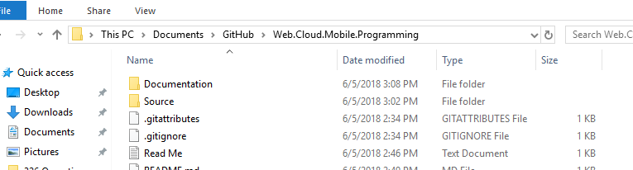

3.Take screenshots of a repository creation and put them in the documentation folder in the local repository and sync it to remote repository

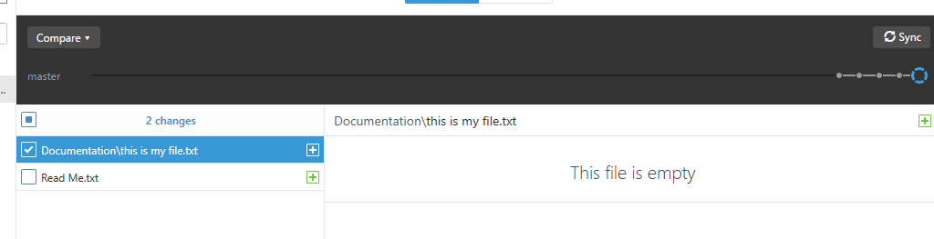

4.Create an html document named “index.html” and place it in the source folder. Inside the html document write a report explaining what you did during the creation of the Git repository with screenshots included as images. The page should contain paragraphs, headings, unordered list, an ordered list, at least two div & span elements, at least four block and inline elements. The screenshots stored in documentation should be displayed as images at appropriate locations in the html file and should be clickable i.e. when you click the image, it should redirect you to the location of the image in the documentation in a new tab. The page should also include a relevant

YouTube video -The video should have controls like play, pause, etc.

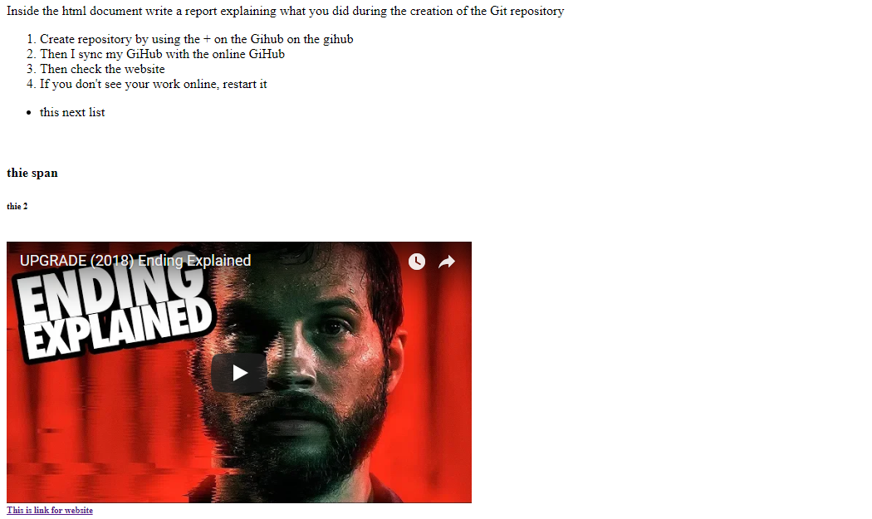

5. Sync both local repository with the source and documentation folders with the remote repository.



CSS Task

Add to Google

1. Download the Source Code and run the starter code given in the InClass folder with Webstorm

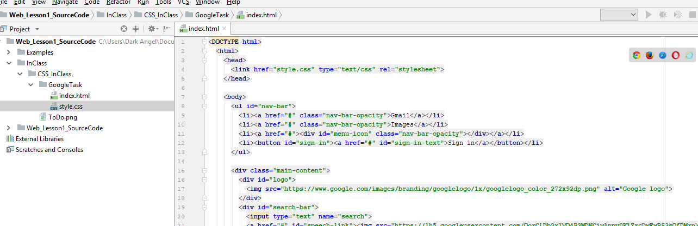

1. Add the notification icon and your image in the corner of the page and the recently opened tab below the search bar of google as shown in the image

